

**ESKİŞEHİR TECHNICAL UNIVERSITY**

**FACULTY OF ENGINEERING**

**COMPUTER ENGINEERING**

**2021-2022 SPRING SEMESTER**

**BIM312**

**DATABASE MANAGEMENT SYSTEMS**

**TERM PROJECT**

PHASE-2

**G9-PNo9:** University Club Membership Database System

**Çağla ŞEN - 38996140066**

**Radwan Rachid HOUSSEIN -99936402866**

Contents

**E/R Diagram** 3

The Relational Schema 4

Database Schema (SQL codes) 5

## [**E/R Diagram**](https://github.com/RadwanH/University-Club-Membership/blob/main/Diagrams/ER-Diagram.drawio.png?raw=true)

(you click the title to see the diagram on the web of better view / it is attached as a .png file as well)

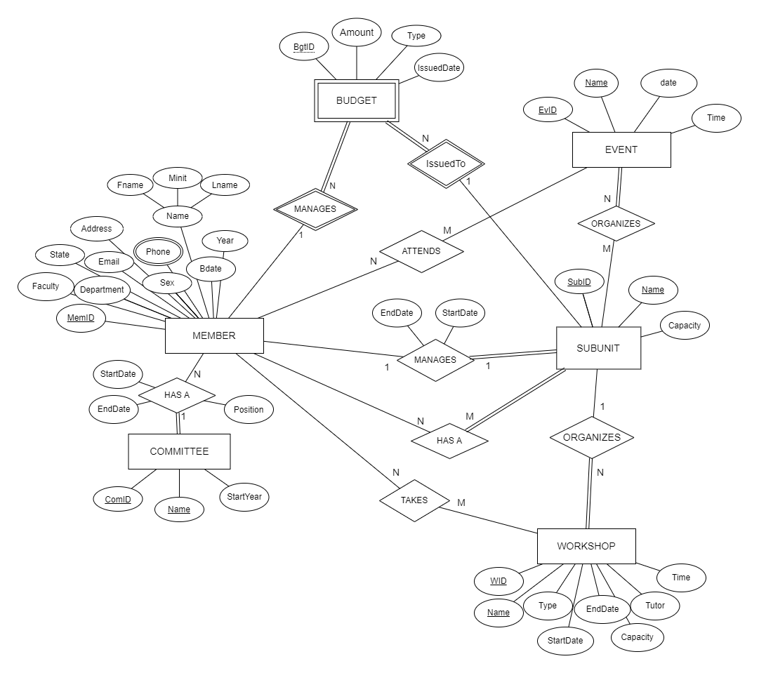

# The Relational Schema

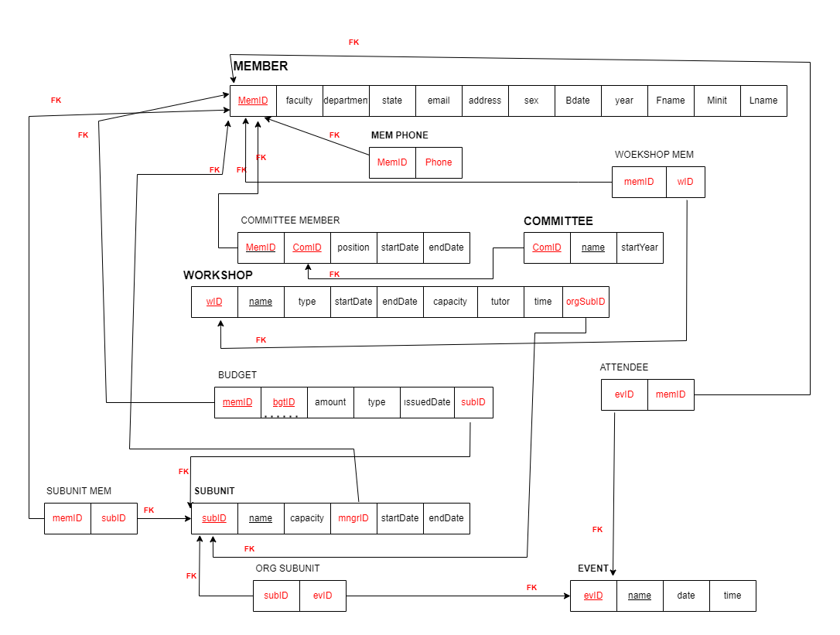[[HERE]](https://github.com/RadwanH/University-Club-Membership/blob/main/Diagrams/Untitled%20Diagram.drawio.png?raw=true)

# Database Schema (SQL codes)

**CREATE TABLE CLUB_MEMBER**

(`member_id` CHAR(9) NOT NULL,

`first_name` VARCHAR(15) NOT NULL,

`minit` varchar(1),

`last_name` VARCHAR(15) NOT NULL,

`sex` CHAR(1),

`birth_date` DATE,

`faculty` VARCHAR(50),

`department` VARCHAR(50) NOT NULL,

`year` INT(1) NOT NULL,

`email` VARCHAR(30) NOT NULL,

`address` VARCHAR(50),

`membership_state` VARCHAR(7) NOT NULL,

ADD PRIMARY KEY (`member_id`));

);

**CREATE TABLE `COMMİTTEE`**

(`com_id` İNT(5) NOT NULL,

`com_name` VARCHAR(30) NOT NULL,

`start_year` YEAR NOT NULL

);

**CREATE TABLE `COMMİTTEE_MEM**`

(`com_member_id` CHAR(9) NOT NULL,

`com_id` İNT(5) NOT NULL,

`position` VARCHAR(30) NOT NULL,

`start_date` DATE,

`end_date` DATE

);

**CREATE TABLE `BUDGET`**

(`mngr_id` CHAR(9) NOT NULL,

`bgt_id` İNT(5) NOT NULL,

`bgt_amnt` DOUBLE(7,2) NOT NULL,

`bgt_type` VARCHAR(50),

`issuedto_subid` İNT(5) NOT NULL,

`issued_date` DATE );

**CREATE TABLE `SUB_UNİT`**

(`sub_id` İNT(5) NOT NULL,

`sub_name` VARCHAR(50) NOT NULL,

`sub_capacity` İNT(4) NOT NULL,

`mngr_id` CHAR(9) NOT NULL,

`sub_start_date` DATE,

`sub_end_date` DATE );

**CREATE TABLE `WORKSHOP`**

(`w_id ` İNT(5) NOT NULL,

`w_name` VARCHAR(50) NOT NULL,

`w_type` VARCHAR(30),

`w_start_date` DATE,

`w_end_date` DATE,

`w_capacity` İNT(4) NOT NULL,

`tutor` VARCHAR(30) NOT NULL,

`time` TİME,

`org_sub_id` İNT(5) NOT NULL

);

**CREATE TABLE `MEM_PHONES`**

(`member_id` CHAR(9) NOT NULL,

`phone` VARCHAR(20)

);

**CREATE TABLE `EVENT**`

(`ev_id` İNT(5) NOT NULL,

`ev_name` VARCHAR(50) NOT NULL,

`ev_date` DATE,

`time` TİME NOT NULL);

**CREATE TABLE `ATTENDEE`**

(`ev_att_id` CHAR(9) NOT NULL,

`ev_id` İNT(5) NOT NULL

);

**CREATE TABLE `WORKSHOP_MEM`**

(`w_member_id` CHAR(9) NOT NULL,

`w_id` İNT(5) NOT NULL,

);

**CREATE TABLE `SUB_MEM`**

(`sub_mem_id` CHAR(9) NOT NULL,

`sub_id` İNT(5) NOT NULL

);

CREATE TABLE `ONG_SUB`

(`org_ev_id` İNT(5) NOT NULL,

`ev_id` İNT(5) NOT NULL

);

# SQL EER Diagram